Substance Institute

presents

Module 7

Homework -
Cognitive Behavior Therapy

Homework – Module 7 – Cognitive Behavior Therapy

Name: ___________________ Date:_____/______/_____

Question 1: In your own words – Cognitive Behavior Therapy.
____________________________________________
____________________________________________
____________________________________________
____________________________________________
____________________________________________
____________________________________________
____________________________________________
____________________________________________
____________________________________________
____________________________________________
____________________________________________
____________________________________________
____________________________________________
____________________________________________
____________________________________________
____________________________________________
____________________________________________
________________________________________________________________________________________

Question 2: Explain CBT Techniques For Insomnia (_____)
____________________________________________
____________________________________________
____________________________________________
____________________________________________
____________________________________________
____________________________________________
____________________________________________
________________________________________________________________________________________

Question 3: Explain Cognitive Emotional Behavioral Therapy (_______)
____________________________________________
____________________________________________
____________________________________________
____________________________________________
____________________________________________
____________________________________________
____________________________________________
________________________________________________________________________________________
____________________________________________
____________________________________________
Question 4: Explain the three-phase process that trains the client to use skills (_______)
____________________________________________
____________________________________________
____________________________________________
____________________________________________
____________________________________________
____________________________________________
____________________________________________
________________________________________________________________________________________
____________________________________________
____________________________________________

Question 5: Explain What Cognitive Behavior Therapy Can Help With (_______)
____________________________________________
____________________________________________
____________________________________________
____________________________________________
____________________________________________
____________________________________________
____________________________________________
________________________________________________________________________________________
Question 6: From this picture list the disorders that could benefit from Cognitive Behavioral Therapy (_______)

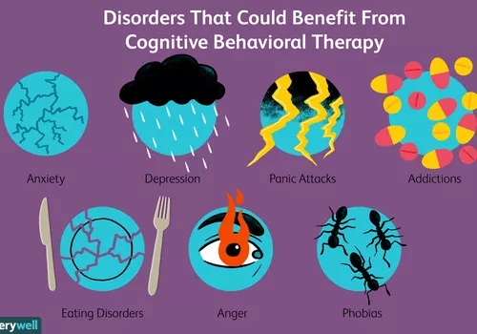
- _________________________________________
- _________________________________________
- _________________________________________
- _________________________________________
- _________________________________________
- _________________________________________
- _________________________________________

Question 7: Select 17 0f the 21 Best CBT Techniques That Psychologists Use: (________)

- ________________________________________
- ________________________________________
- ________________________________________
- ________________________________________
- ________________________________________
- ________________________________________
- ________________________________________
- ________________________________________
- ________________________________________
- ________________________________________
- ________________________________________
- ________________________________________
- ________________________________________
- ________________________________________
- ________________________________________
- ________________________________________
- ________________________________________

