Substance Institute – Intercessor’s Diploma
STUDENT’S LESSON 1
Intercessors Spiritual Defenders
Intercessor’s Spiritual Development Program

Written, Compiled & Instructor:
Dr. Althea Winifred, Ph.D.,
Professor & Dean

Table of Contents
Welcome Letter 3
About an Intercessors Spiritual Defender (ISDefender) 5
Module 1 - Defend / Protection and the Lifesaver of the Church 5
Introducing Understanding Spirituality 8
Spiritual Development 9
Praying and the Word 9
The Spiritual Awakening 10
C.O.M.A. 12
What is an Intercession Precept? 17
IS Defenders - Duties of An Intercessor 19
Growing and Praying Defensively 19
As a (ISDefender) are never in Catch 22 21
Module 1 - Homework - Defend / Protection and the Lifesaver of the Church 22
Lesson 1 - Bible Character - David’s Prayer Life 25

Welcome Letter

Welcome the Substance Institute – Spiritual Development Program – Intercessors Spiritual Defenders!

Thank you for enrolling in Substance Institute - Spiritual Development Program is an online biblical course offering a Quality and Affordable Biblical Education. Throughout this course, we believe in you as our students to become educated, empowered, equipped and edified to achieve a Biblical Education for God's Assignment in the Spiritual Development Program.

This is a 6-month course that is create design to learn about Intercessor’s Spiritual Development. Each Intercessors Spiritual Defenders class is 2 hours (1.5 hours of lecture plus 25 minutes of Q&A and 5 minutes of praying time - opening / closing prayers). Each class will include a new lesson and a new doctrine, open discussion and require monthly homework of fill in the blanks from the lesson being taught.

After completing all 6-classes, students will receive the Substance Institute - Intercessors Spiritual Defenders Classes Certificate of Completion which should be kept in their records.
​Your Substance Institute - Intercessors Spiritual Defenders Classes Certificate of Completion will be emailed to you within 24-48 hours after the course has ended.

Our Mandate ~ Substance Institute is to prepare a people unto the Lord by thinking outside of the box by become perfected, edified and equipped with the word of God as a spark in God’s hand to ignite a nation movement that crosses all denominational, ethnic, and cultural backgrounds to reconciliation, discipleship, and godliness through preparation.

Our Purpose ~ Substance Institute is a Christ-centered biblical education school dedicated to instructing teaching and guiding all students learning for the perfecting of the saints, for the work of the ministry, for the edifying of the body of Christ to have godly influences and affluence in their world.

Our Goal ~ Substance Institute is committed to equipping our students to achieve a biblical education that they will grow in knowledge and be accomplishing God's goals in their world.

Our Aim ~ is to work with you as our student to reach their personal and spiritual study.

The Spiritual Development Program have one common theme - to give a wisdom about the Intercessors Spiritual Defenders by exalting Jesus; to present God's truth and allowing the Holy Spirit to give you wisdom, knowledge, discernment and understand to achieve to your assignments from God.

Our staff are prepared and committed to helping you during this course as you reach for your goals of learning about the Intercessors Spiritual Defenders.

May God enrich, empower, and encourage your life, help you to bloom, flow and grow in Jesus, and bless you as you train for service in His Kingdom.

Once again, welcome to Substance Institute!

Under His Wing & In His Service,
Dr. Althea Winifred, Ph.D.

About an Intercessors Spiritual Defender (ISDefender)

- Stands in the _______________,
- Stands in the _______________
- Make up the _______________ (put a safeguard which a provision and protection what concerns you)
- Stand my _______________,
- Stand in the _______________,
- _______________ a boundary that not pass this line,
- operate in _______________ and
- Has _______________ with authenticity.

And I sought for a man among them, that should make up the hedge, and stand in the gap before me for the land, that I should not destroy it: but I found none. Ezekiel 22:30 KJV

Module 1 - Defend / Protection and the Lifesaver of the Church
You hold 3 positions in 3 different dimensions
- __________________________________________________________
- __________________________________________________________
- __________________________________________________________
Intercessors Spiritual Defenders (ISDefender) is program to help all intercessors to pray defensively in the spirit. ISDefender will prayer spiritually which is their weapon by interceding on behalf of their church needs, Pastors, Leaders, all departments, family, friends, community, cities, nations and all that God leads them to for pray.

- When you see / hear the word defend what do you think about?

- When you see / hear the word protection what do you think about?

- When you see / hear the phrase “the Lifesaver of the Church” what do you think about?
The word “defend”
__________________________________________________________________________________________________________________________________________________________________________________________________

The word “protection”
__________________________________________________________________________________________________________________________________
_________________________________________________________________
The word “lifesaver”
_________________________________________________________________
_________________________________________________________________
_________________________________________________________________
You are in the spiritual war that the fight has been won; there is a winner and a loser. The fight has been fixed.

As intercessors,

- You are the defender.
- You are the game and atmosphere changers,
- You are shifter of the spirit,
- You are definer of the ambiance and
- Your prayers are protector of the environment.
- ______________________________________
- ______________________________________
- ______________________________________
- ______________________________________
- ______________________________________

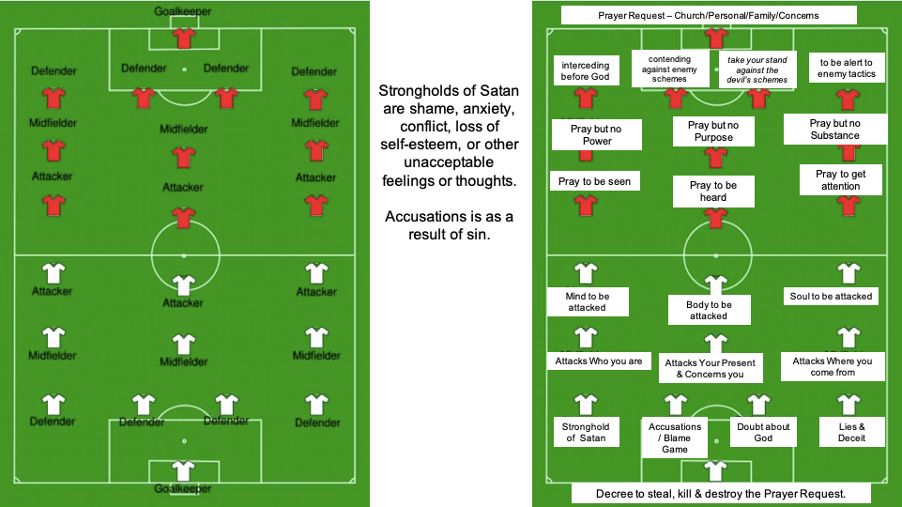

Introducing Understanding Spirituality

You have entered into a major place in the Lord.

Spiritual praying is a major ___________ is being spiritual.

Jesus became flesh and dwell amongst us as human. He had to put on humanity in order to function here on earth.

Now is the time for God’s people to become ___________ and put on ___________ to be able to dwell with Him in the spirit.

You ___________ to your flesh is one thing.

Giving up ___________ is another.

Leaving _____ you know is yet another.

Becoming ___________ is only done by the Lord.

____________ has changed but the Lord is the same.

___________ you enter into as a seed into a womb.

___________ is being perfected, entering into maturity and becoming complete in I the Lord.

Spiritual Advancement

As ISDefenders, we must become equipped, become educated, become encouraged, become empowered for the advancement of your relationship with the Lord and being an intercessor.

And I sought for a man among them, that should make up the hedge, and stand in the gap before me for the land, that I should not destroy it: but I found none. Ezekiel 22:30 KJV

Praying and the Word

ISDefenders exists to help others to ___________, ____________, and ___________ into Spiritual Develop intercessors.

- ___________ muscles
- Be ___________ in righteousness in Christ Jesus.
- Effectively ask each other for ___________and support.
- Find ___________ and ___________ help by furthering your Bible read and
- Every day ___________ in your heavenly position to build up your most holy faith for 6 minutes and reading the daily scripture.
- Never get stuck wondering what to study in the Bible daily.
- Discuss ___________ in the ISDefenders community with others.
- Everlasting ___________ in the Word of God the Bible through praying and
- Study ___________ ISDefender’s ________________ set.
- Reading, ___________ will be and must be done daily.

__________________________________________________________________________________________________________________________________
___________________________________________________________________________________________________________________________________________________________________________________________________
___________________________________________________________________________________________________________________________________________________________________________________________________
___________________________________________________________________________________________________________________________________________________________________________________________________

The Spiritual Awakening

This Spiritual ___________ will be time where God aligns all things in order for the end time days.

God’s will cause the ___________ to become aware of who they are in Him.

God will cause His ___________ to a raise and be aware and to consider their ways to become His.

There will be a sudden awareness of God’s will, work, word, ways, wisdom, worth and wealth which the Holy Spirit will allow on the people who want more of His.

And the angel that talked with me came again, and waked me, as a man that is wakened out of his sleep. Zechariah 4:1 KJV

Guidelines about the Awakening

- To God’s ____________ and attributes ____________
- To ____________ God’s still small voice
- Understand God’s ____________
- To become God’s ____________ upon the earth
- God’s Remnants are being acknowledged by themselves that they are God’s selected and elected for such a time as this.
- This ____________ of God is becoming suddenly aware of God’s ____________, ____________, ____________, ____________, ____________, ____________ and ____________.
- The church will arise and become spiritual advisor to ____________ because set order has been aligned.

Who art thou, O great mountain? before Zerubbabel thou shalt become a plain: and he shall bring forth the headstone thereof with shouting, crying, Grace, grace unto it. Zechariah 4:7 KJV

22 Types of Spirituality when they pray as Intercessors
- Spiritual ________________________
- Spiritual ________________________
- Spiritual ________________________
- Spiritual ________________________
- Spiritual ________________________
- ________________________ Spiritual ________________________
- Spiritual ________________________
- Spiritual ________________________
- Spiritual ________________________
- Spiritual ________________________
- Spiritual ________________________
- Spiritual ________________________
- Spiritual ________________________
- Spiritual ________________________
- Spiritual ________________________ Ring
- Spiritual ________________________
- ________________________ Spiritual ________________________
- A Spiritual ________________________ Redefined
- A Spiritual ________________________ with _______________________
- Spiritual ____________ is ____________, ____________ and ____________ by the Holy Spirit.
- Spiritual ________________________ from a natural man to spiritual man ____________
- Spiritual ________________________ in Leadership that works and operates in the Spirit’s ____________.

C.O.M.A.

As an ISDefender, we will be focusing on C.O.M.A.

Coma is not “a state of prolonged unconsciousness, including a lack of response to stimuli, from which it is impossible to rouse a person.” (dictionary.com)

ISDefenders’ coma are as follows:
- A Spiritual Characteristics about Intercession
- A Spiritual Outlook on Intercession
- A Spiritual Moral Nature for Intercession
- A spiritual Approach of Intercession

A Spiritual Characteristics about Intercession

- Damnations - Matthew 23:33 KJV - “Ye serpents, ye generation of vipers, how can ye escape the damnation of hell?”
- Darkness - 1 Peter 2:9 KJV - “But ye are a chosen generation, a royal priesthood, a holy nation, a peculiar people; that ye should shew forth the praises of him who hath called you out of darkness into his marvelous light:”
- Deceit - Psalm 101:7
- Deceive - 1John 1:8
- Declare - Isaiah 42:9
- Decree - Daniel 3:10
- Resistance against attack - James 4:6-11
- Defending

  - Job 22:25
  - Psalm 59:17
  - Ecclesiastes 7:12
  - Acts 22:1
  - Philippians 1:17

- Delight - Psalm 40:8
- Deliverance - Psalm 32:7
- Desire - Proverbs 13:19
- Destroy - John 10:10

A Spiritual Outlook on Intercession

Direction - Numbers 21:18
Direct
                - Psalm 5:3
                - Proverbs 3:6
                - Isaiah 40:13
                - 2 Thessalonians 3:5

A Spiritual Moral Nature for Intercession
- 2 Peter 1:4
- James 3:6
- Hebrews 2:16
- Ephesians 2:3
- Galatians 4:8
- Galatians 2:15
- 1 Corinthians 11:14
- Romans 2:27
- Romans 2:14
- Romans 1:26

A Spiritual Approach of Intercession

- To draw near to God - ________________________
- To come - ________________________
- To dwell in Your courts - ________________________
- To have a Pure Heart - ________________________
- To have access - ________________________
- To have confidence - ________________________
- To Know the Lord - ________________________
- To Pray - ________________________
- To Search - ________________________
- To speak - ________________________
- To stand - ________________________
- To take the Water of Life - ________________________

Spiritual Development

With your Spiritual Development, you will have these experiences that you go through some happen together and some happen individually but know that you will go through all these aspects within the next 6 classes:
- ________________________ is beginning with deep reverence for God
    - ________________________ - Ephesians 1:17
    - ________________________ - Proverbs 2:1-8, Job 28:12-28
    - ________________________ - James 3:15-17
- Spiritual Knowledge - Proverbs 1:7
    - ________________________ - 2 John 1:6-9
- Spiritual Power
    - ________________________ - Ephesians 3:13
    - ________________________ - Ephesians 3:13
    - ________________________ - Ephesians 3:20
- Spiritual Growth - These are different stages of development
    - 1). ________________________
    - 2). ________________________
    - 3). ________________________
    - 4). ________________________
    - 5). ________________________
- Spiritual Struggles
    - ________________________ - Ephesians 6:14-17
    - ________________________ - James 4:7
    - ________________________ - 1 Thessalonians 5:8-11
    - ________________________
- Spiritual Fruitfulness
    - ________________________ - Colossians 1:9
    - ________________________ - John 15:4-6
    - ________________________ - John 15:1-2, 16
- Spiritual Identity
    - ________________________ - John 15:16
    - ________________________ - John 5:24
    - ________________________ - John 1:12
    - ________________________ - John 3:15-16
    - ________________________ - John 8:31-32
    - ________________________ - 1 Corinthians 6:17
    - ________________________ - John 10:10
    - ________________________ - 2 Cor. 5:18
    - ________________________ - 2 Corinthians 5: 19
    - ________________________ - 2 Cor. 5:17
- Spiritual Authority
    - ________________________ - Mark 11:22-23
    - ________________________ - Mark 11:24
    - ________________________ - Mark 11:25-26
- Spiritual Purpose
    - ________________________ - Jeremiah 29:15
    - ________________________ - Jeremiah 29:14
    - ________________________ - Jeremiah 29:13
- Combat Spiritual Warfare
    - Spiritual ________________________
    - Spiritual ________________________
    - Spiritual ________________________
    - Spiritual ________________________
      - Lack of ________________________ & Purpose
      - Extreme ________________________
      - ________________________ About Purpose
        - ________________________ Attacks
        - Pressure

- A Spiritual Warrior
    - Awareness
    - ________________________
    - ________________________
    - ________________________
    - Patience
    - ________________________
    - Love
- All Spiritualities is begin ________________________, ________________________ & ________________________ by The Holy Spirit

What is an Intercession Precept?

Precept is the teaching, rule, guidelines, instruction, law,

Make me to understand the way of thy precepts: so, shall I talk of thy wondrous works. Psalm 119:27 (KJV)

In the scriptures the word which is translated "Precept" is a general term for the responsibility God places upon His people.

________________________ The precepts keep us from blaming God or others for our problems.

________________________ The precepts keep us from error because they are founded on God's truth. Each precept is an attempt to set forth a biblical truth.

________________________ Our understanding and practice of the precepts will improve if we get started doing what we are able to do.

________________________ The ten precepts of ISDefenders seek to transform the heart of the addict and to develop qualities essential for deliverance from the bondage of addiction and promote spiritual growth.

____________ ____________ & ____________.

1. Honesty: Romans 3:23

2. Humility: Ezekiel 14:1-8

3. Surrender: Acts 16:31, Philippians 3:8 & Romans 10:9

____________ ____________ & ____________.

4. Dependability: Proverbs 28:13

5. Repentance: James 5:16 & I John 1:9

6. Aid: Philippians 2:12-12 & II Timothy 2:2

____________ ____________ ____________ & ____________.

7. Discipline: Hebrews 4:12

8. Deference: Philippians 3:10-11, Luke 22:42

9. Dispense: Hebrews 10:25

10. Compassion: Matthew 28:19-20

IS Defenders - Duties of An Intercessor

Isaiah 62:6-7 - I have posted watchmen on your walls, Jerusalem; they will never be silent day or night. You who call on the Lord, give yourselves no rest, and give him no rest till he establishes Jerusalem and makes her the praise of the earth.

As ISDefenders, it is time to grow in our wisdom, knowledge, understanding, discernment and faith in the character of the Lord as revealed in the scriptures.

An ISDefender is one who fights (or pleads) for justice, to prevail on behalf of another. Isaiah 59:15-16 -KJV

An ISDefender (intercessor) is one who builds or creates the wall or hedge of protection. Ezekiel 13:4-5 KJV

An ISDefender (intercessor) is one who stands between God’s judgment and His person or people and pleads for mercy. Ezekiel 22:29-30 KJV

Our duties as ISDefenders are grow in effectiveness as intercessors, we must always desire for spiritual wisdom, spiritual knowledge, spiritual understanding and spiritual discernment so that we grow in the experiential spiritual development of God.

Growing and Praying Defensively

The Scripture says in Ephesians 4:15 that we should grow in all things.
- Colossians 1:10 - __________________________.
- _______________________ through prayer.
- Proverbs 13:11 - __________ &____________, ______________through praying.
- Isaiah 29:19 - _______________________during praying.
- 2 Thessalonians 1:3 - _______________________.
- 1 Thessalonians 3:12 and 1 Thessalonians 4:9-10 - _______________________for others with compassion.
- Ephesians 2:21 - _______________________.
- Luke 2:52 _______________________.
- Luke 2:52 - _______________________with the model of Jesus as our intercessors.
- 2 Peter 3:18 - _______________________. Become deeply grateful for God’s grace, His favor in your life.

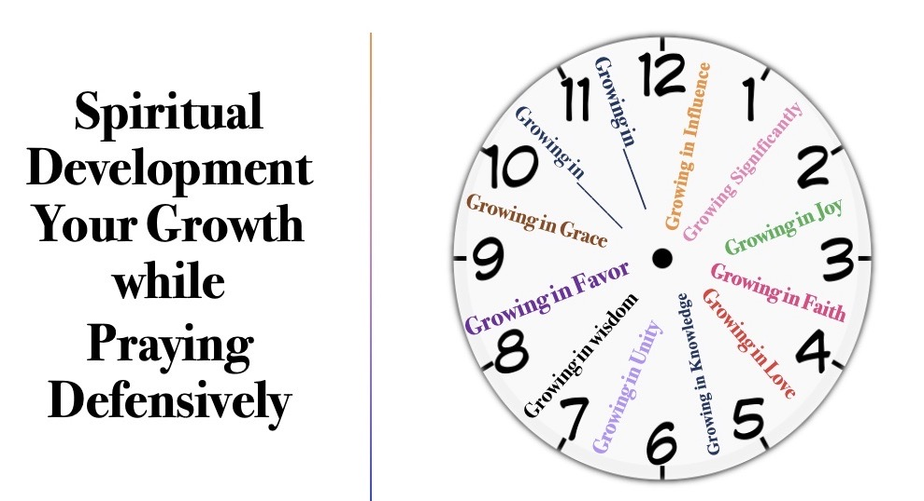
ISDefenders Growth

As a (ISDefender) are never in Catch 22

- ISDefenders are given that assignment(s) to pray “when there is no escape because of mutually conflicting or dependent conditions”.
- ISDefenders look at situation and make a way to go through and know and the enemy or people on Satan’s assignments will become fish food.
- ISDefenders pray in the spiritual position of all or nothing are something that’s left over from what was at one time that was a much larger portion or number of things or people.
- ISDefenders have been rejected to become rerouted in the Lord and not reduced.
- ISDefenders are the people that see and help to prevent catastrophe sudden damage from happening.
- ISDefenders starts off seeing the “result from rules, regulations, or procedures that an individual is subject to, but has no control over, because to fight the rule is to accept it” but when you pray from the place of righteousness in Christ Jesus and in the same position as Jesus in heavenly places far above principalities and powers and knowing that your assignment is to pray to the Creator your assigner who has all power and nothing is in possible.
- ISDefenders know that if God does it is okay and if God doesn’t do it is because He is in control, and if God decides to do nothing it is okay because He knows best.
- ISDefenders will stay CCC staying Cool, Calm, and Collective because we are being used by God who has already won.

SII Faith School – Intercessor’s Diploma

Intercessors Spiritual Defenders
Intercessor’s Spiritual Development Program

Homework

Module 1 - Homework - Defend / Protection and the Lifesaver of the Church

Name: _____________________________ Date: _____/______/______

- How will you involve prayer in your Spiritual Development?
_________________________________________________________________
_________________________________________________________________
_________________________________________________________________

- What are the duties of an intercessors?
_________________________________________________________________
_________________________________________________________________
_________________________________________________________________

- What is spiritual development to you?
__________________________________________________________________________________________________________________________________________________________________________________________________________________________________________________________________
_________________________________________________________________

- Explain the C.O.M.A of an intercessor?
__________________________________________________________________________________________________________________________________________________________________________________________________________________________________________________________________
_________________________________________________________________

- As a (ISDefender) are never in Catch 22; what does this mean? List 2 (two)
___________________________________________________________________________________________________________________________________________________________________________________________________________________________________________________________________________________________________________________________________

- Out of the 12 different Spiritual Development which one (1) means to most to you and why? (Every month you will evaluate yourself to see where you are at in your spiritual development
__________________________________________________________________________________________________________________________________________________________________________________________________________________________________________________________________
_________________________________________________________________
_________________________________________________________________________________________________________________________________________________________________________________________________
_________________________________________________________________

- What are the 2 areas you would like to grow in this month & why?
___________________________________________________________________________________________________________________________________________________________________________________________________

Biblical Character’s
Homework

Lesson 1 - Bible Character - David’s Prayer Life
“Trust in Him at all times; ye people, pour out your heart before Him: God is a refuge for us.” Psalm 62:8.

Introduction
“David’s prayer was continually directed to God. His trust was in God, and he walked before Him in a perfect way.”.

King David in the Bible – Who Was He? Why Is He Important?
“O God, you are my God; I shall seek You earnestly; My soul thirsts for You, my flesh yearns for You, in a dry and weary land where there is no water. Thus, I have seen You in the sanctuary, to see Your power and Your glory. Because Your lovingkindness is better than life. My lips will praise You.” (Psalm 63:1-3)

Did you know that more has been written about David than any other biblical character?
Sixty-six (66) chapters are dedicated to him. That doesn’t include fifty-nine (59) references to him in the New Testament.

How important do you think King David was to Israel?
David was young when Samuel found him. David had been shuffled off to his father’s fields to work as a shepherd boy. His father must have viewed him as trustworthy and responsible to give him sole care of his herds. In reality, he was in God’s training ground learning to be a king.

Israel's Backstory
The nation of Israel was living in turbulent spiritual times. The leaders wanted a king like the other nations. They were tired of worshipping a king they couldn’t see. Slowly and over time, they had fallen away from the LORD.

“And it came about when Samuel was old that he appointed his sons’ judges over Israel... His sons, however, did not walk in his ways…” (I Samuel 8:1, 3)

“Then all the elders of Israel gathered together and came to Samuel at Ramah, and said to him, "Look, you are old, and your sons do not walk in your ways. Now make us a king to judge us like all the nations.” (I Samuel 8:4-5)

“But the thing was displeasing in the sight of Samuel when they said, 'Give us a king to judge us.' And Samuel prayed to the LORD. The LORD said to Samuel, 'Listen to the voice of the people in regard to all that they say to you, for they have not rejected you, for they have rejected Me from being king over them.'” (I Samuel 8:6-7, emphasis added)

Samuel spoke on behalf of the LORD and gave Israel warnings regarding requesting a king. They refused to listen to Samuel.

The LORD told Samuel to appoint them a king. (I Samuel 8:10-22)

God must have felt the sting of rejection.

The Rise and Fall of Saul
Saul, the people’s choice, was chosen to be king. He started out strong. He slowly declined until his life ended tragically and in disgrace.

“Samuel said to Saul, ‘You have acted foolishly; you have not kept the commandment of the Lord your God, which He commanded you, for now the Lord would have established your kingdom over Israel forever. For now, your kingdom shall not endure. The Lord has sought out for Himself a man after His own heart, and the LORD has appointed him as ruler over His people, because you have not kept what the LORD commanded you.” (I Samuel 13:13-14)

God rejected Saul as king.
It was time for God to intervene. It was time for God to put His man on the throne--and He was going to use Samuel to help Him do just that.

“Now the LORD said to Samuel, ‘How long will you grieve over Saul, since I have rejected him as king over Israel? Fill your horn with oil and go; I will send you to Jesse the Bethlehemite, for I have selected a king for Myself among his sons.” (I Samuel 16:1, emphasis added)

David Is Anointed as King
Samuel followed the instructions of the LORD despite his fears. He came to the home of Jesse. He saw his son Eliab. Based on his appearance, he thought surely this is the LORD’s choice.

“But the LORD said to Samuel, ‘Do not look at his appearance or at the height of his stature, because I have rejected him; for God sees not as man sees, for man looks at the outward appearance, but the LORD looks at the heart.” (I Samuel 16:7, emphasis added)

After inquiring, Samuel finds out that Jesse has one more son, his youngest, who is tending sheep.

“Then Samuel said to Jesse, ‘Send and bring him; for we will not sit down until he comes here.’ So, he sent and brought him in. Now he was ruddy, with beautiful eyes, and a handsome appearance. And the LORD said, ‘Arise, anoint him; for this is he.’” (I Samuel 16:11b-12)

“Then Samuel took the horn of oil and anointed him in the midst of his brothers; and the Spirit of the LORD came mightily upon David from that day forward. And Samuel arose and went to Ramah.” (I Samuel 16:13)

According to Charles R. Swindoll, Josephus, the historian, says, “Samuel the aged whispered in his [David] ear the meaning of the symbol, ‘You will be the next king.’”

David was anointed as king while Saul was still on the throne.

God's "Training Ground" for David
David’s father had sent him off to the fields to watch over the family flock. He spent hours alone tending sheep. He learned the meaning of surviving in the wild. He slept out under the cover of darkness. He learned to endure the change of seasons and weather the elements. Surely, loneliness was his constant companion.
No doubt, he had many conversations with God while he was living alone in solitude. We can see proof of this in his writings in the Psalms.

David also lived in complete obscurity.
“Men and women of God, servant-leaders in the making, are first unknown, unseen unappreciated, and applauded. In the relentless demands of obscurity, character is built. Strange as it may seem, those who first accept the silence of obscurity are best qualified to handle the applause of popularity.” (Chuck Swindoll)

Chuck Swindoll describes one of God’s favorite methods of training as monotony: “That’s being faithful in the menial, insignificant, routine, regular, unexciting, uneventful, daily tasks of life. Life without a break…without the wine and roses.

Just dull, plain L-I-F-E.

Just constant, unchanging, endless hours of tired monotony as you learn to be a man or woman of God…with nobody else around, when nobody else notices, when nobody even cares. That’s how we learn to ‘king it.’”

David’s Resumé
David was “a skillful musician, a mighty man of valor, a warrior, one prudent in speech, a handsome man,” and the LORD was with him. (I Samuel 16:18)
We also see from the many Psalms that David was a talented musician and a songwriter. His gentleness as a harpist reveals his true inner sensitivity as an artist.
While David was tending the flock, he was learning to play the harp. God was preparing him to serve a king.

“Now the Spirit of the Lord departed from Saul, and an evil spirit from the Lord terrorized him.” (I Samuel 16:14)
Saul’s servants knew about David and they sent for him on Saul’s command to find someone who could play well.

“Then David came to Saul and attended him; and Saul loved him greatly, and he became his armor bearer.” (I Samuel 16:21)

Whenever the evil spirit from God overwhelmed Saul, David would play his harp and Saul would calm down and be refreshed, and the evil spirit would leave Saul alone. (I Samuel 16:23)

David's Courage
Even as a young man, he was given the responsibility of protecting the family's herd of sheep.

“...Your servant was tending his father’s sheep. When a lion or a bear came and took a lamb from the flock, I went after him and attacked him, and rescued it from his mouth; and when he rose up against me, I seized him by his beard and struck him and killed him." (I Samuel 17:34-35)

This is the reality that David had been living and the training ground God had been using to prepare David to be king one day.

He is best known for killing the giant Goliath with a sling and stone.

Everything David did in the sight of the people was pleasing to them. Everywhere Saul sent him, he prospered. (I Samuel 18)

It was David’s success as a mighty warrior that fueled Saul’s jealousy. When he heard the women dancing in the streets singing, “Saul has slain his thousands, And David his ten thousand,” Saul became very angry. (I Samuel 18:7)

He turned against David. He pursued David for the rest of his life.

King David's Great Sin
“Then it happened in the spring, at the time when kings go out to battle…But David stayed in Jerusalem.” (2 Samuel 11:1)

David’s choice to stay back was poor leadership and wasn’t his usual practice. His decision was bad judgment on his part and set the stage for his devastating fall into iniquity.

“Now when evening came David arose from his bed and walked around on the roof of the king’s house, and from the roof he saw a beautiful woman bathing; and the woman was very beautiful in appearance.” (2 Samuel 11:2) He looked. He inquired. He sent for her.

“The woman conceived; and sent and told David, and said, ‘I am pregnant.” (2 Samuel 11:5)

Deception | Conspiracy | Murder | Lying |
David conspired to have her husband killed in the field of battle so that he could take Bathsheba as his wife.

Nathan the prophet rebuked David severely. “Then David said to Nathan, 'I have sinned against the LORD.' And Nathan said to David, 'The LORD also has taken away your sin; you shall not die.'” (2 Samuel 12:13)

Sadly, David and Bathsheba lost the child that she bore to David. “Then David comforted his wife Bathsheba and went into her and lay with her; and she gave birth to a son, and he named him Solomon.

Now the LORD loved him and sent word through Nathan the prophet, and he named him Jedidiah [“Beloved of the LORD”] for the LORD’s sake.” (2 Samuel 12:24-25, emphasis added)

Death of King David
"Then David slept with his fathers and was buried in the city of David. The days that David reigned over Israel were forty years; seven years he reigned in Hebron and thirty-three years he reigned in Jerusalem." (I Kings 2:10-11)

"And Solomon sat on the throne of David his father, and his kingdom was firmly established." (I Kings 2:12)

Over 400 years separated the final events and final prophecy recorded in the Old Testament (424 B.C.) from the beginning actions narrated in the New Testament (6 B.C.) Because there was there was no prophetic word from God during this time, this period is sometimes called “the four hundred silent years.” Though the voice of God was silent, the hand of God was actively directing the course of events during these centuries.

“So, all the generations from Abraham to David are fourteen generations; from David to the deportation to Babylon fourteen generations; and from the deportation to Babylon to the Messiah, fourteen generations.” (Matthew 1:17, emphasis added)
“Thus, says the LORD of hosts, 'Your house and your kingdom shall endure before Me forever; your throne shall be established forever.' In accordance with all these words and all this vision, so Nathan spoke to David.” (2 Samuel 7:16-17, emphasis added)

EARNEST CONSISTENCY
- What habit can we learn from David - and why? Psalm 55:16, 17.
__________________________________________________________________________________________________________________________________________________________________________________________________
- Describe the depth of spiritual experience we are to learn from David’s example. Psalm 38:9–15; 42:1, 2, 5; 84:2.
___________________________________________________________________________________________________________________________________________________________________________________________________________________________________________________________________
_________________________________________________________________________________________________________________________________

BEHOLDING GOD’S CHARACTER
- How did David gain a clearer view of God through prayer? Psalm 77:1–14.
___________________________________________________________________________________________________________________________________________________________________________________________________________________________________________________________________
__________________________________________________________________________________________________________________________________
- What tragic hour in David’s life confirms how outward circumstances do not necessarily reflect whether or not God accepts our prayers? Psalm 3:1–8.
___________________________________________________________________________________________________________________________________________________________________________________________________________________________________________________________________
__________________________________________________________________________________________________________________________________
DEEP REPENTANCE
- Despite the greatest sin of David’s life, what attitude had enabled him to be restored as a man after God’s own heart? Psalms 32:1, 2; 51:1–14; 103:13.
___________________________________________________________________________________________________________________________________________________________________________________________________________________________________________________________________
__________________________________________________________________________________________________________________________________

- What assurances are given to repentant souls? Jeremiah 3:22; Matthew 5:4.
___________________________________________________________________________________________________________________________________________________________________________________________________________________________________________________________________
__________________________________________________________________________________________________________________________________

RESTORATION TO PURITY
- What must we always remember about God? Psalm 145:8, 9; 1 John 4:16.
___________________________________________________________________________________________________________________________________________________________________________________________________________________________________________________________________
________________________________________________________________________________________________________________________________
- On what theme did David often focus his prayers? Psalms 19:12–14; 51:10.
___________________________________________________________________________________________________________________________________________________________________________________________________________________________________________________________________
__________________________________________________________________________________________________________________________________
THE REWARD OF FERVOR

- How can we enjoy a rich spiritual life? Psalm 119:10, 145.
___________________________________________________________________________________________________________________________________________________________________________________________________________________________________________________________________
__________________________________________________________________________________________________________________________________

- What characterizes all who truly take God at His word? Psalms 50:23; 51:15.
___________________________________________________________________________________________________________________________________________________________________________________________________________________________________________________________________
_________________________________________________________________________________________________________________________________

